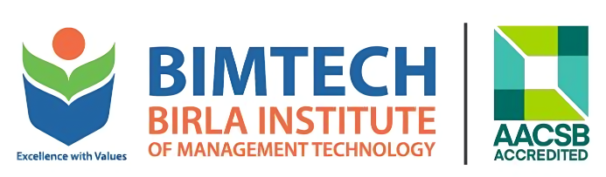


PR REPORT
AUGUST 2026
Prepared By


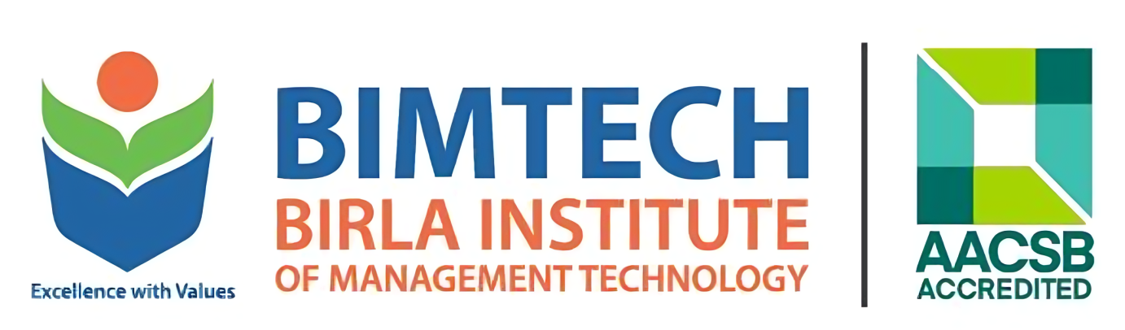
Activity Sheet – August 2026
- Press Release: BIMTECH Inaugurates Centre of Excellence on AI, Strengthening Focus on AI-Led Learning and Innovation

- Article: How to rule the Indian Roost – Prof. Jyoti Sankar Das – Dinamalar

- Article: Ethanol Blending: The Two Sides of a Story - Prof. Monika Jain - Governance Now

- Industry Story: PharmEasy expands into AI physiotherapy as investors push for profits - Prof. Jyoti Sankar Das - Fortune India

- Industry Story: If AI can give MBA Students the answers. What Should Business Schools Teach - Dr. T.V. Raman - ET Education

PR DOCUMENT

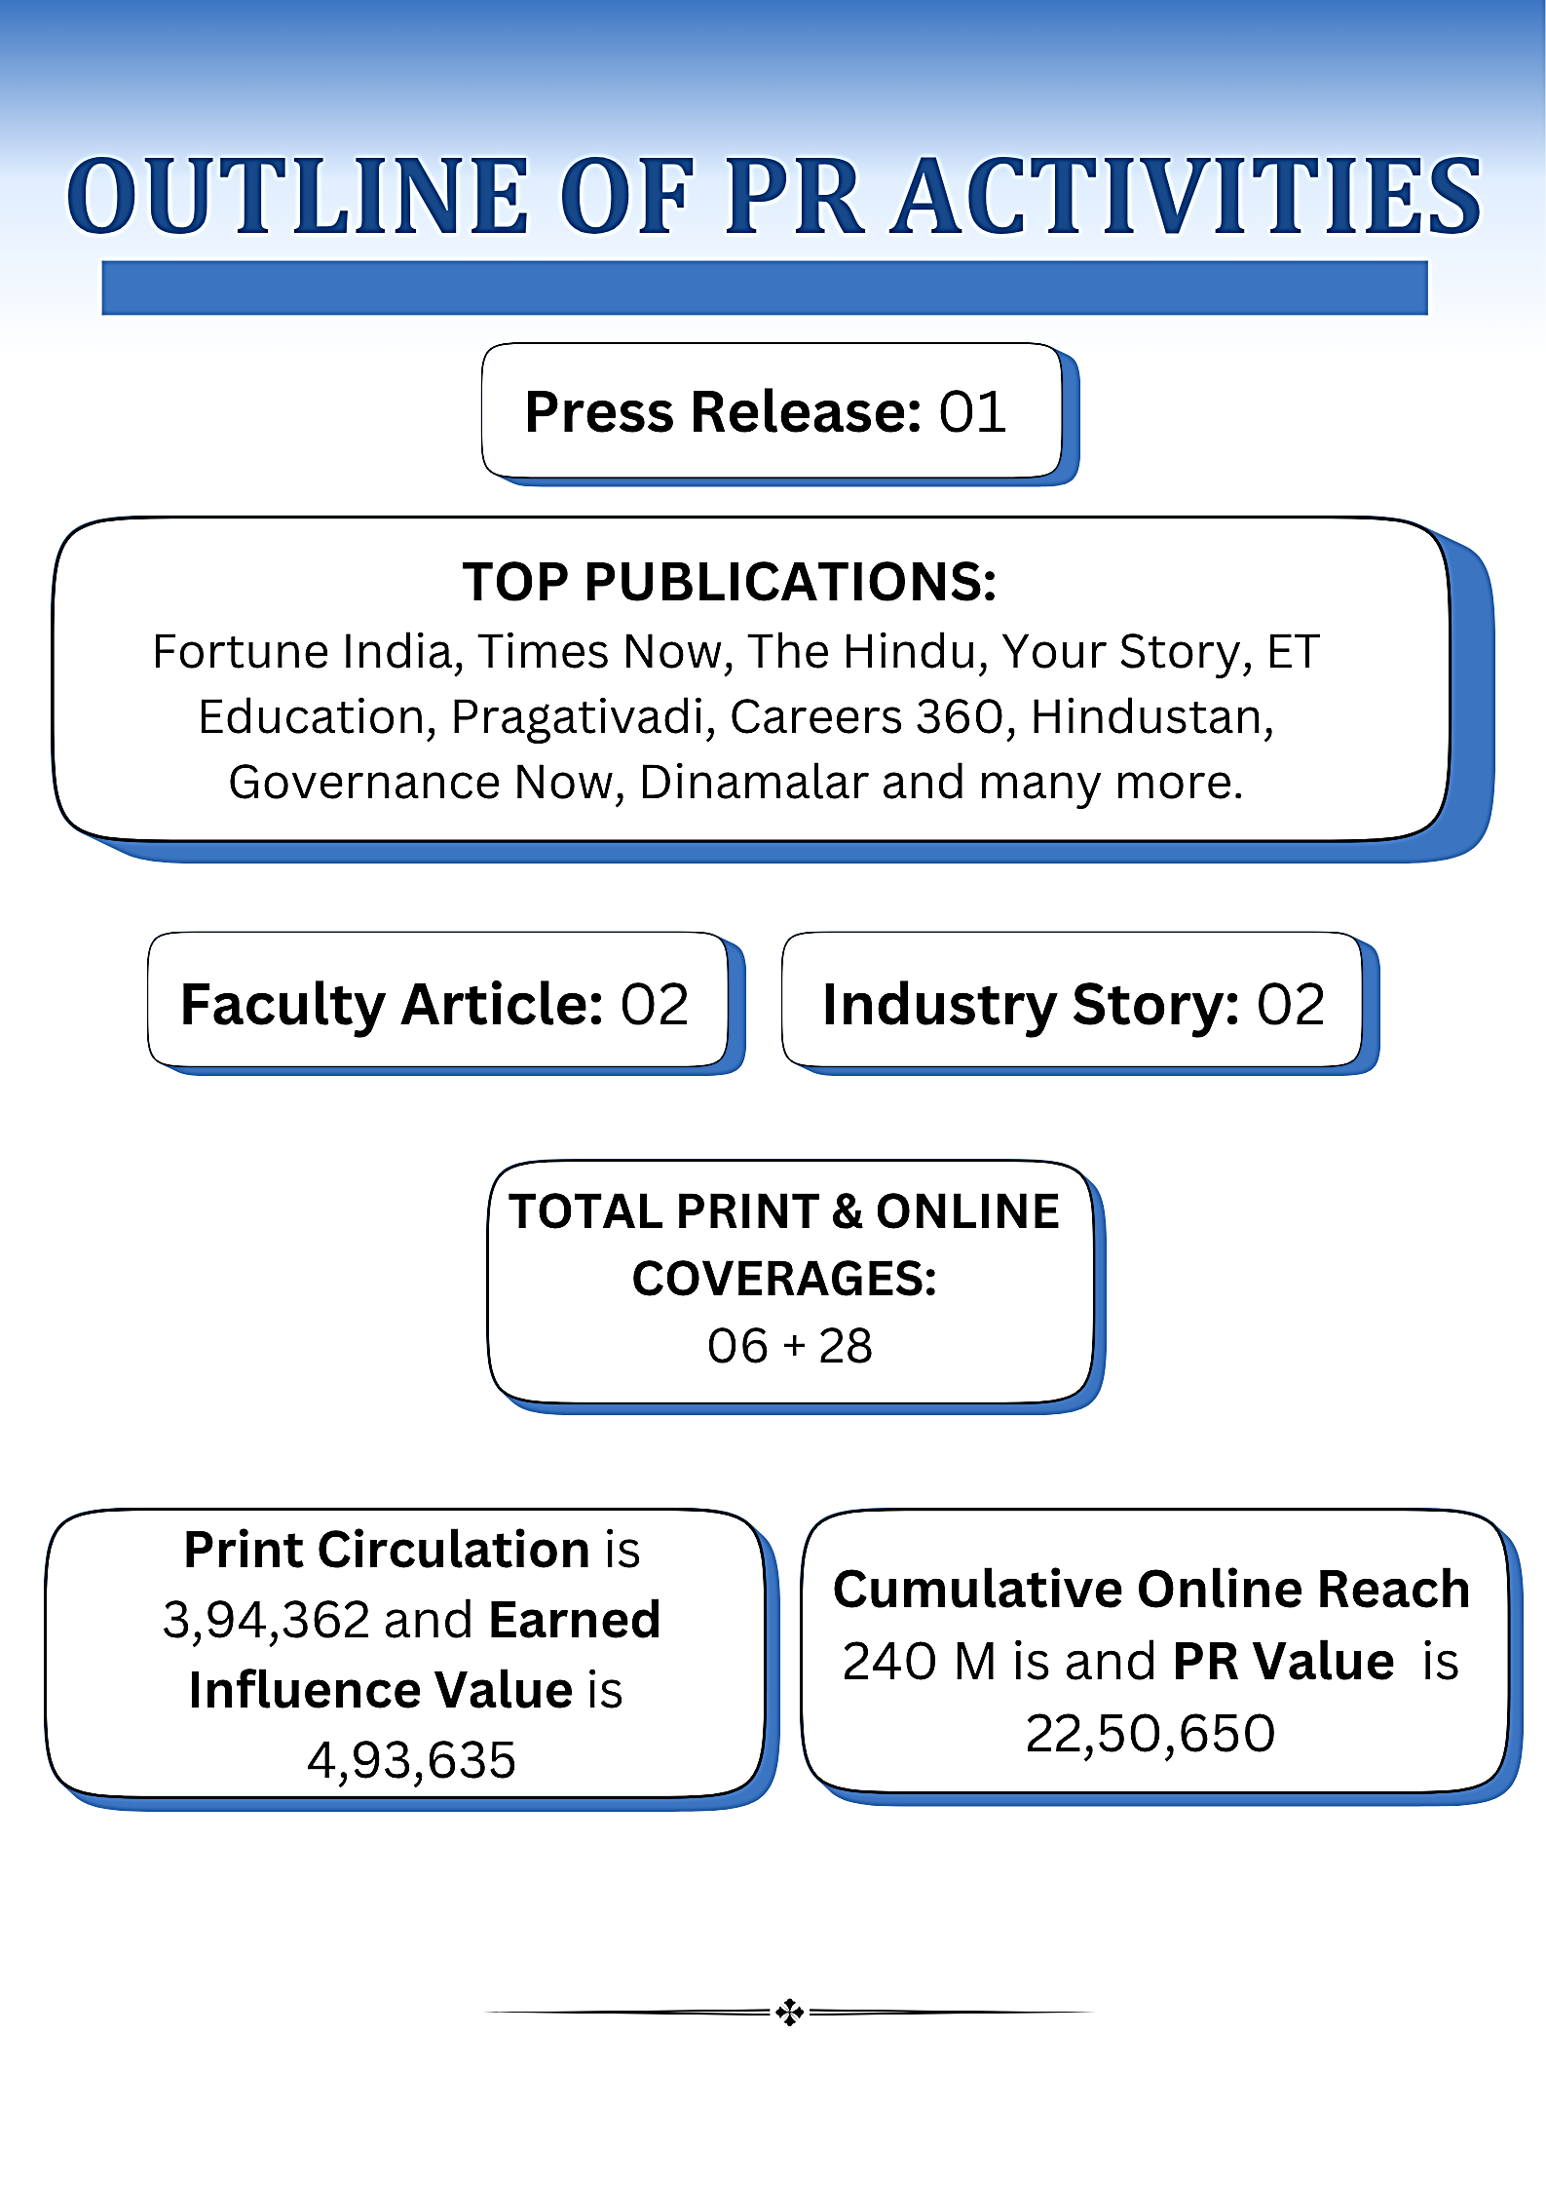

Press Release: BIMTECH Inaugurates Centre of Excellence on AI, Strengthening Focus on AI-Led Learning and Innovation
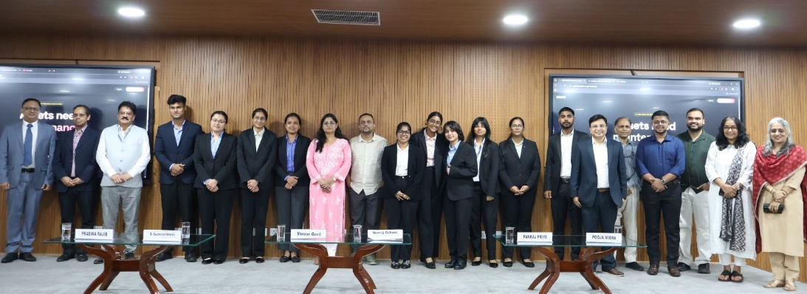

Press Release
BIMTECH Inaugurates Centre of Excellence on AI, Strengthening Focus on AI-Led Learning and Innovation
OR
BIMTECH Strengthens AI Innovation Ecosystem with Inauguration of Centre of Excellence on AI
National, August 20, 2026: Rooted in experiential learning and innovation, Birla Institute of Management Technology (BIMTECH), a leading AACSB-accredited business school in India, successfully inaugurated its Centre of Excellence on AI on August 19, 2026, marking a significant step in strengthening the institute’s focus on artificial intelligence, experiential learning, innovation and technology-driven education.
The inauguration of the AI Centre of Excellence brought together 400+ participants, primarily students and faculty members, under the vision Learn. Build. Deploy. Innovate. The event was graced by advisory board members Mr. Neeraj Gehani, Global Product Director, Dunnhumby; Mr. Varoon Govil, Executive Director, MSCI Inc.; and Dr. Saumendra Mohanty, Consultant, ValueFirst (a Tanla Company), and highlighted the institute’s continued efforts to foster hands-on learning, experimentation, and the practical application of emerging technologies.
As part of the programme, participants underwent a structured learning programme designed to build a strong foundation in AI and modern development workflows. The programme covered AI Fundamentals, the Generative AI ecosystem, Google AI Studio, Google Antigravity, Google Cloud Credits and resources, and live project development and deployment. Through hands-on activities, interactive learning and project development exercises, participants gained practical exposure to AI tools and technologies and learnt how to take their ideas from concept to working solutions. Participants explored key problem areas including MedTech, FinTech, EdTech and Open Innovation, identifying real-world challenges where AI and emerging technologies could create meaningful impact. The open-ended format encouraged teams to think creatively, collaborate and develop innovative, scalable solutions.
Emphasising the importance of such experiential learning initiatives, Dr. Prabina Rajib, Director, BIMTECH said, “Ideas are only the beginning of innovation. What matters is the ability to take an idea, test it, build it and create something that can address a real problem. The Centre of Excellence on AI marks an important step in strengthening BIMTECH’s commitment to technology-driven and experiential learning. Our aim is to equip students and the wider academic community with the capabilities to learn, build and innovate in an increasingly AI-driven world.”
Participants turned their ideas into AI-powered applications, automation tools and innovative prototypes designed to address practical challenges. The solutions ranged from personalised stock and mutual fund management to applications focused on personal health and care. These projects demonstrated how AI can move beyond experimentation to enable practical and scalable solutions for challenges faced by individuals, organisations and society.
The event also saw participants showcase the solutions they had developed, demonstrating their learning, creativity, teamwork and technical execution. The winning teams were recognised for their innovation, impact, technical execution and overall quality of their solutions. Rank 1 – Wroom Wroom: Kartik Saxena, Kritika Digari, Kumari Shachi, Bhavna Mittal, Rank 2 – LOSER CORE: Bhavya Rawat, Rank 3 – CARPIEDEM: Sakshi Jaiswal, Ruchi Yadav, Rishita Agarwal, Surabhi Singh, Ranjan Kumar Singh.
The top-performing teams were recognised with cash prizes and other accolades for their innovative solutions. All participating students and participants were also awarded certificates in recognition of their involvement and contribution to the programme.
The inauguration of the Centre of Excellence on AI reinforces BIMTECH’s continued focus on building a future-ready academic community through experiential learning, industry collaborations, workshops, hackathons, research and student-led projects. By creating platforms where emerging technologies can be explored and ideas can be developed into practical solutions, BIMTECH continues to strengthen the connection between classroom learning, innovation and real-world application.
प्रेस विज्ञप्ति
बिमटेक में एआई सेंटर ऑफ एक्सीलेंस की शुरुआत, एआई-बेस्ड लर्निंग और इनोवेशन पर जोर
नेशनल, 20 अगस्त 2026। बिरला इंस्टीट्यूट ऑफ मैनेजमेंट टेक्नोलॉजी (बिमटेक),में बुधवार को एआई सेंटर ऑफ एक्सीलेंस की शुरुआत हुई। इस मौके पर 400 से ज्यादा स्टूडेंट्स और शिक्षक मौजूद रहे। कार्यक्रम में स्टूडेंट्स को एआई की विभिन्न तकनीकों की जानकारी दी गई और उन्हें इनका इस्तेमाल करते हुए अपने विचारों पर काम करने का अवसर मिला।

कार्यक्रम की थीम ‘लर्न. बिल्ड. डिप्लॉय. इनोवेट.’ रही। इस दौरान स्टूडेंट्स को एआई की बुनियादी जानकारी के साथ जनरेटिव एआई, गूगल एआई स्टूडियो, गूगल एंटीग्रैविटी और गूगल क्लाउड जैसी तकनीकों से परिचित कराया गया। स्टूडेंट्स ने इन तकनीकों को खुद आजमाते हुए अपने विचारों पर काम किया और उन्हें प्रोजेक्ट्स के रूप में तैयार किया।

कार्यक्रम में डन्हम्बी के ग्लोबल प्रोडक्ट डायरेक्टर नीरज गेहानी, एमएससीआई इंक. के एग्जीक्यूटिव डायरेक्टर वरुण गोविल और वैल्यूफर्स्ट (तनला कंपनी ) के कंसल्टेंट डॉ. सौमेंद्र मोहंती भी शामिल हुए। उन्होंने स्टूडेंट्स के साथ नई तकनीकों और उनके इस्तेमाल से जुड़े अनुभव साझा किए।

कार्यक्रम के दौरान स्टूडेंट्स ने मेडटेक, फिनटेक, एडटेक और ओपन इनोवेशन से जुड़े अलग-अलग विषयों पर काम किया। उन्होंने संबंधित समस्याओं को समझने के बाद टीमों में मिलकर एआई की मदद से उनके संभावित समाधान तैयार किए। इस दौरान स्टूडेंट्स ने यह भी समझा कि किसी समस्या को पहचानने से लेकर उसके समाधान के लिए एक विचार को प्रोजेक्ट के रूप में कैसे विकसित किया जा सकता है।

इस मौके पर डॉ. प्रबीना राजिब , डायरेक्टर, बिमटेक ने बताया “किसी भी नए काम की शुरुआत एक विचार से होती है। लेकिन असली काम तब शुरू होता है जब उस विचार को परखा जाए, उस पर काम किया जाए और उसे किसी वास्तविक समस्या के समाधान में बदला जाए। एआई सेंटर ऑफ एक्सीलेंस बिमटेक में टेक्नोलॉजी और प्रैक्टिकल लर्निंग को बढ़ावा देने की दिशा में एक महत्वपूर्ण कदम है। हमारा प्रयास है कि स्टूडेंट्स तेजी से बदलती एआई की दुनिया में नई चीजें सीखने, बनाने और नए प्रयोग करने के लिए तैयार हों।”

स्टूडेंट्स ने इस दौरान एआई की मदद से ऐप, ऑटोमेशन टूल और अलग-अलग प्रोजेक्ट तैयार किए। इनमें शेयर और म्यूचुअल फंड से जुड़े समाधान के साथ-साथ हेल्थ और पर्सनल केयर से जुड़े प्रोजेक्ट भी शामिल रहे। इन प्रोजेक्ट्स के जरिए स्टूडेंट्स ने एआई के प्रैक्टिकल यूज़ को समझते हुए अलग-अलग समस्याओं के समाधान पर काम किया।

कार्यक्रम में स्टूडेंट्स ने एआई की मदद से तैयार किए गए अपने प्रोजेक्ट प्रस्तुत किए। प्रोजेक्ट्स का मूल्यांकन नए आइडिया, उपयोगिता, टेक्नोलॉजी और समस्या के समाधान के आधार पर किया गया। बेहतर प्रदर्शन करने वाली टीमों को कैश प्राइज दिए गए। फर्स्ट प्राइज कार्तिक सक्सेना, कृतिका डिगारी, कुमारी शाची एवं भावना मित्तल की टीम को, सेकंड प्राइज भाव्या रावत को और थर्ड प्राइज साक्षी जायसवाल, रुचि यादव, रिशिता अग्रवाल, सुरभि सिंह एवं रंजन कुमार सिंह की टीम को मिला। इसके अलावा अन्य प्रतिभागियों को भी सम्मानित किया गया। कार्यक्रम में शामिल सभी स्टूडेंट्स को सर्टिफिकेट दिए गए।

बिमटेक में शुरू हुए एआई सेंटर के तहत वर्कशॉप, हैकाथॉन, रिसर्च और स्टूडेंट प्रोजेक्ट्स पर काम किया जाएगा। इसके जरिए स्टूडेंट्स को पढ़ाई के साथ एआई और दूसरी नई तकनीकों को समझने और उन पर काम करने का मौका मिलेगा।

PRINT
COVERAGES

INDEX
Press Release: BIMTECH Inaugurates Centre of Excellence on AI, Strengthening Focus on AI-Led Learning and Innovation
Sr. No. | Date | Publication | Page No. | Edition | Circulation | EIV
1 | 21.08.2026 | Hindustan | 2 | Greater Noida | 1,96,800 | 2,65,950
2 | 21.08.2026 | Alpviram | 8 | Ahmedabad | 25,000 | 27,850
3 | 21.08.2026 | Pradesh Express | 2 | Bhopal | 15,344 | 17,050
4 | 21.08.2026 | Dainik Purnviram | 7 | Bhopal | 25,000 | 27,550
5 | 21.08.2026 | Dainik Vishwadirgha | 3 | Bhopal | 25,000 | 27,645
6 | 22.08.2026 | Herald Young Leader | 7 | Ahmedabad | 1,07,218 | 1,27,590
TOTAL |  |  |  |  | 3,94,362 | 4,93,635

PUBLICATION: Hindustan
DATE: 21.08.26
PAGE No. 02
EDITION: Greater Noida

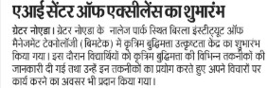

PUBLICATION: Alpviram
DATE: 21.08.26
PAGE No. 08
EDITION: Ahmedabad

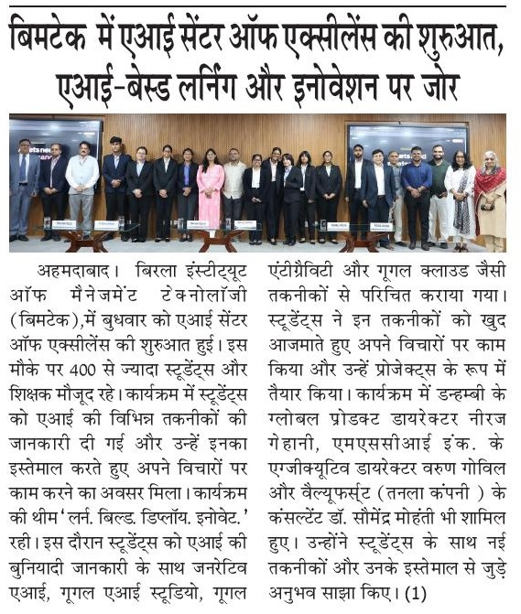

PUBLICATION: Pradesh Express
DATE: 21.08.26
PAGE No. 02
EDITION: Bhopal
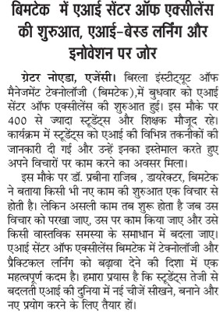

PUBLICATION: Dainik Purnviram
DATE: 21.08.26
PAGE No. 07
EDITION: Bhopal
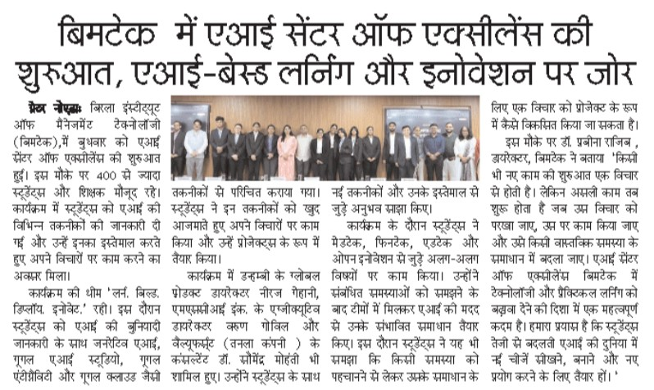

PUBLICATION: Dainik Vishwadirgha
DATE: 21.08.26
PAGE No. 03
EDITION: Bhopal
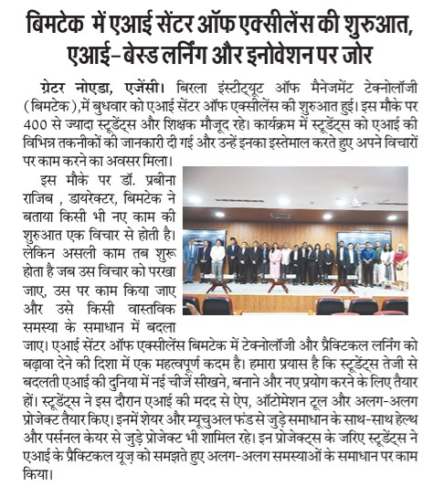

PUBLICATION: Herald Young Leader
DATE: 22.08.26
PAGE No. 07
EDITION: Ahmedabad

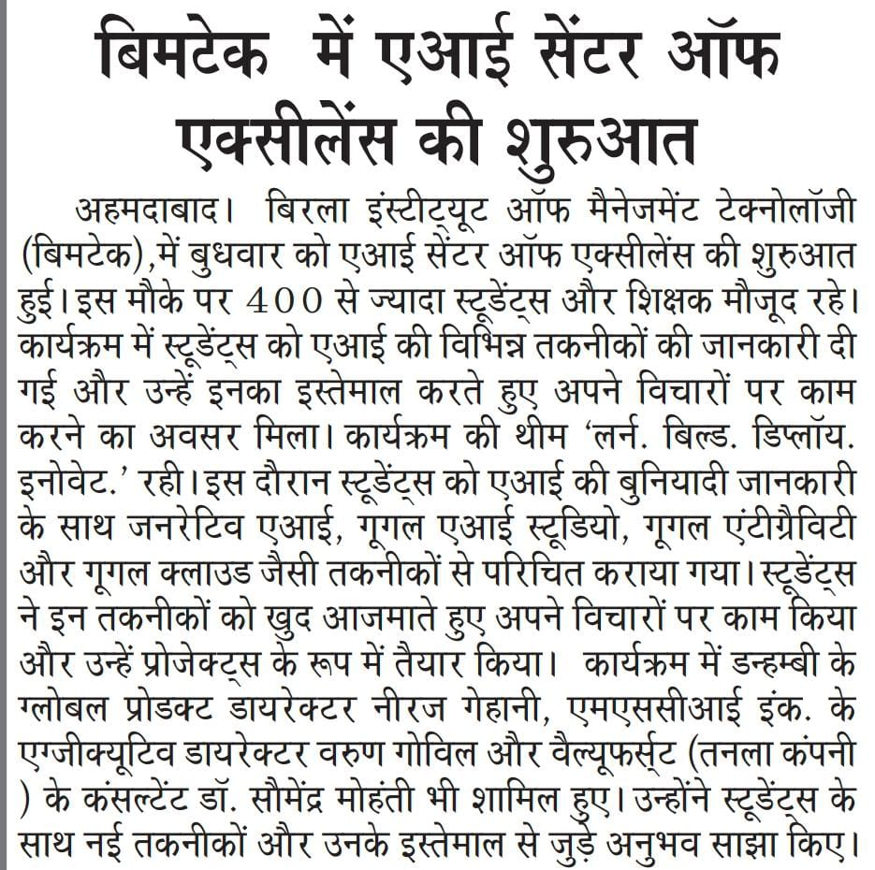

INDEX
Press Release: BIMTECH Inaugurates Centre of Excellence on AI, Strengthening Focus on AI-Led Learning and Innovation
Sr. No. | Publication | Link | Reach | PR Value
1 | Times Now | https://www.timesnownews.com/education/bimtech-launches-centre-of-excellence-in-ai-to-strengthen-experiential-learning-innovation-and-industry-collaboration-article-155865977/amp | 36M | 2,55,200
2 | The Hindu | https://www.thehindu.com/education/news-from-the-world-of-education-august-21-2026/article71375242.ece | 38M | 1,91,400
3 | Your Story | https://yourstory.com/2026/08/startup-news-and-updates-daily-roundup-august-20-2026 | 10M | 1,92,500
4 | ET Education | https://education.economictimes.indiatimes.com/amp/news/incubation-centres/bimtech-launches-ai-centre-of-excellence-trains-students-in-real-world-ai-applications/133373366 | 37M | 6,39,100
5 | Pragativadi | https://pragativadi.com/bimtech-inaugurates-centre-of-excellence-on-ai-fostering-innovation-and-learning/ | 1M | 3,05,550
6 | Careers 360 | https://news.careers360.com/bimtech-launches-centre-of-excellence-ai-boost-learning-innovation-tech-driven-education-artificial-intelligence-students-faculty/amp | 66M | 1,56,500
7 | Camp Sutra | https://campusutra.com/bimtech-strengthens-ai-innovation-ecosystem/ | NA | NA
8 | MBA Rendezvous | https://www.mbarendezvous.com/b-school-events/bimtech-inaugurates-centre-of-excellence-on-ai/ | NA | NA
9 | SME Channels | https://smechannels.com/bimtech-inaugurates-centre-of-excellence-on-ai-strengthening-focus-on-ai-led-learning-and-innovation | NA | NA
10 | Digital Terminal | https://digitalterminal.in/tech-companies/bimtech-inaugurates-centre-of-excellence-on-ai-to-drive-innovation-and-future-ready-learning | NA | NA
11 | Passionate in Marketing | https://www.passionateinmarketing.com/bimtech-inaugurates-centre-of-excellence-on-ai-strengthening-focus-on-ai-led-learning-and-innovation/ | NA | NA
12 | India Education Diary | https://indiaeducationdiary.in/663424-2/ | NA | NA
13 | Prime 9 Hindi | https://prime9hindi.com/education/bimtech-ai-centre-of-excellence | NA | NA
14 | Konexio Network | https://konexionetwork.com/lifestyle-wellness/bimtech-strengthens-ai-innovation-ecosystem-with-inauguration-of-centre-of-excellence-on-a/ | NA | NA
15 | 3 AM News | https://www.3am.news/education/school-college-updates/bimtech-inaugurates-centre-of-excellence-on-ai-strengthening-focus-on-ai-led-learning-and-innovation | NA | NA
16 | Dainik Insights | https://www.dainikinsights.com/education/school-college-updates/bimtech-inaugurates-centre-of-excellence-on-ai-strengthening-focus-on-ai-led-learning-and-innovation | NA | NA
17 | Bhopal Post News | https://bhopalpostnews.co.in/bimtech-inaugurates-centre-of-excellence-on-ai-strengthening-focus-on-ai-led-learning-and-innovation/ | NA | NA
18 | PNI News | https://www.pninews.com/bimtech-inaugurates-centre-of-excellence-on-ai-strengthening-focus-on-ai-led-learning-and-innovation/ | NA | NA
Social Media
1 | Careers 360 (X) | https://x.com/careers360/status/2090363286663344445 | 9K | NA
2 | Pragativadi (Facebook) | https://www.facebook.com/PragativadiNews/posts/bimtech-inaugurates-centre-of-excellence-on-ai-fostering-innovation-and-learning/1486480156834281/ | 2.2K | NA
3 | Camp Sutra (Linkedin) | https://www.linkedin.com/posts/bimtech-aiineducation-innovation-share-7496068189127192576-n1Q7/ | 3K | NA
4 | UP Words (Facebook) | https://www.facebook.com/upwordsmagazine/posts/rooted-in-experiential-learning-and-innovation-birla-institute-of-management-tec/1713952054071571/ | NA | NA
5 | UP Words (Instagram) | https://www.instagram.com/p/DcTvuh_jKx0/ | NA | NA
TOTAL |  |  | 189M | 17,40,250

https://www.timesnownews.com/education/bimtech-launches-centre-of-excellence-in-ai-to-strengthen-experiential-learning-innovation-and-industry-collaboration-article-155865977/amp

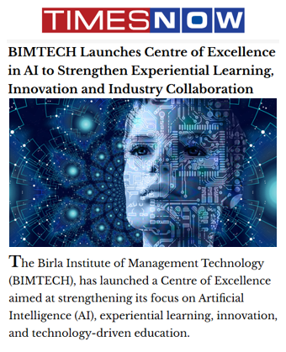

https://www.thehindu.com/education/news-from-the-world-of-education-august-21-2026/article71375242.ece

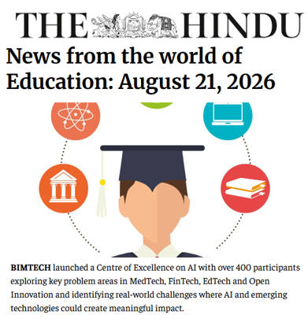

https://yourstory.com/2026/08/startup-news-and-updates-daily-roundup-august-20-2026

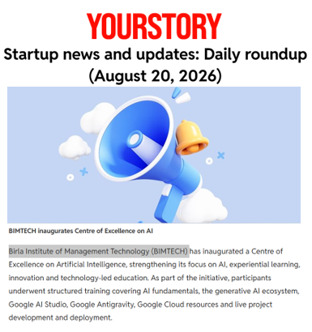

https://education.economictimes.indiatimes.com/amp/news/incubation-centres/bimtech-launches-ai-centre-of-excellence-trains-students-in-real-world-ai-applications/133373366

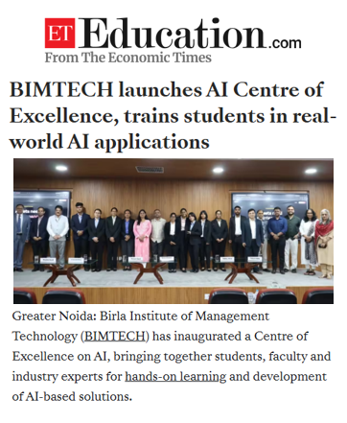

https://pragativadi.com/bimtech-inaugurates-centre-of-excellence-on-ai-fostering-innovation-and-learning/

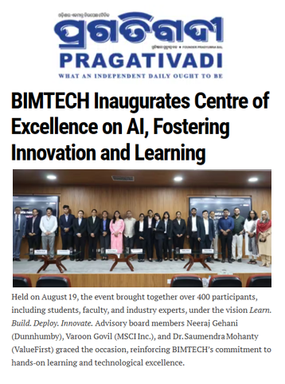

https://news.careers360.com/bimtech-launches-centre-of-excellence-ai-boost-learning-innovation-tech-driven-education-artificial-intelligence-students-faculty/amp

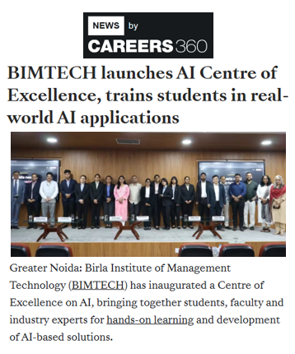

https://campusutra.com/bimtech-strengthens-ai-innovation-ecosystem/

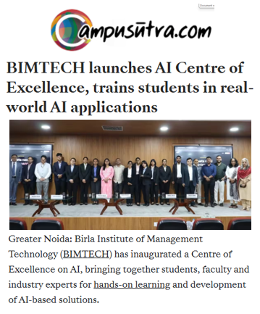

https://www.mbarendezvous.com/b-school-events/bimtech-inaugurates-centre-of-excellence-on-ai/

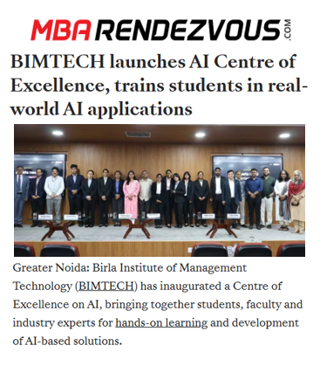

https://smechannels.com/bimtech-inaugurates-centre-of-excellence-on-ai-strengthening-focus-on-ai-led-learning-and-innovation

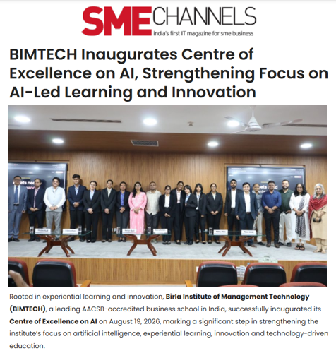

https://digitalterminal.in/tech-companies/bimtech-inaugurates-centre-of-excellence-on-ai-to-drive-innovation-and-future-ready-learning

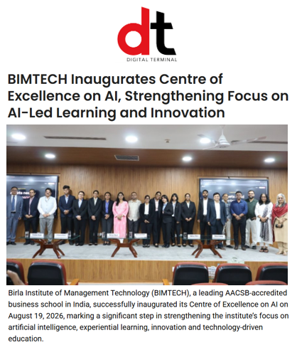

https://www.passionateinmarketing.com/bimtech-inaugurates-centre-of-excellence-on-ai-strengthening-focus-on-ai-led-learning-and-innovation/

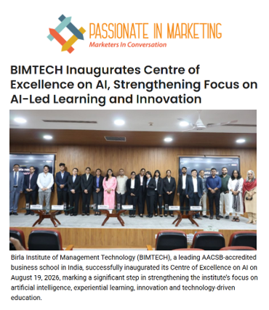

https://indiaeducationdiary.in/663424-2/

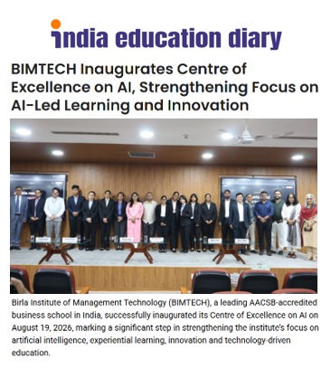

https://prime9hindi.com/education/bimtech-ai-centre-of-excellence

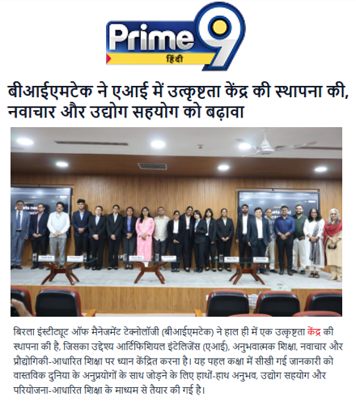

https://konexionetwork.com/lifestyle-wellness/bimtech-strengthens-ai-innovation-ecosystem-with-inauguration-of-centre-of-excellence-on-a/

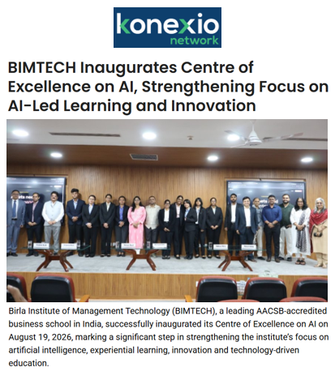

https://www.3am.news/education/school-college-updates/bimtech-inaugurates-centre-of-excellence-on-ai-strengthening-focus-on-ai-led-learning-and-innovation

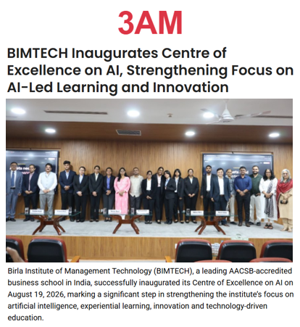

https://www.dainikinsights.com/education/school-college-updates/bimtech-inaugurates-centre-of-excellence-on-ai-strengthening-focus-on-ai-led-learning-and-innovation

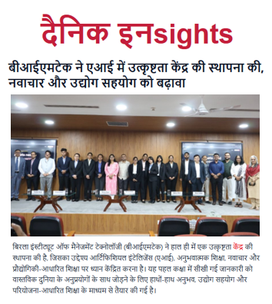

https://bhopalpostnews.co.in/bimtech-inaugurates-centre-of-excellence-on-ai-strengthening-focus-on-ai-led-learning-and-innovation/

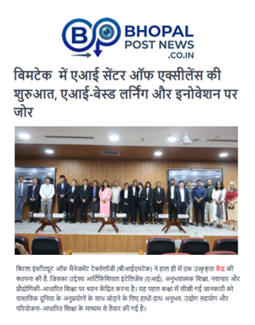

https://www.pninews.com/bimtech-inaugurates-centre-of-excellence-on-ai-strengthening-focus-on-ai-led-learning-and-innovation/

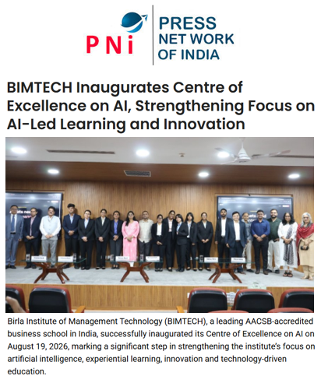

https://x.com/careers360/status/2090363286663344445
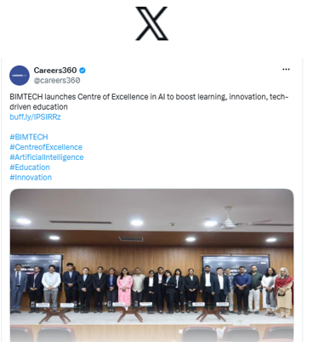

https://www.facebook.com/PragativadiNews/posts/bimtech-inaugurates-centre-of-excellence-on-ai-fostering-innovation-and-learning/1486480156834281/

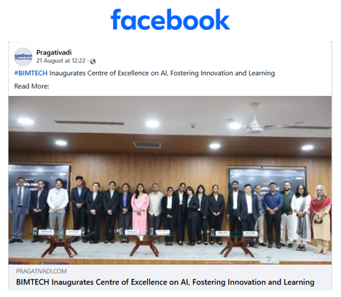

https://www.linkedin.com/posts/bimtech-aiineducation-innovation-share-7496068189127192576-n1Q7/

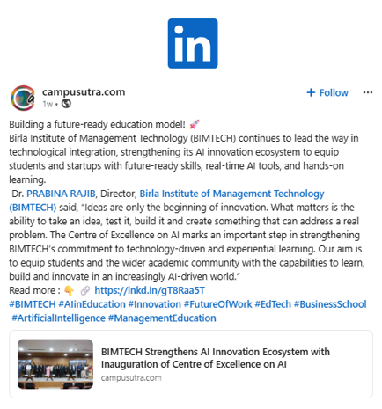

https://www.facebook.com/upwordsmagazine/posts/rooted-in-experiential-learning-and-innovation-birla-institute-of-management-tec/1713952054071571/

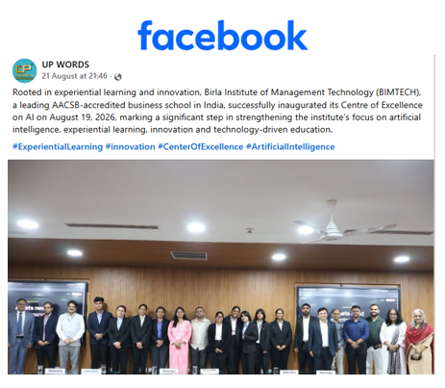

https://www.instagram.com/p/DcTvuh_jKx0/

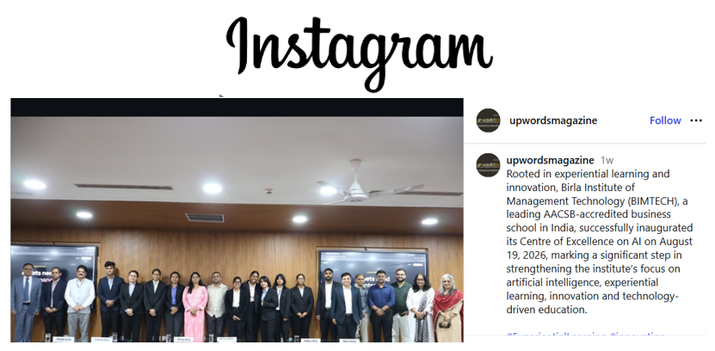

Article: How to rule the Indian Roost – Prof. Jyoti Sankar Das - Dinamalar

INDEX
Article: How to rule the Indian roost - Prof. Jyoti Sankar Das - Dinamalar
Sr. No. | Publication | Link | Reach | PR Value
1 | Dinamalar | https://www.dinamalar.com/news/kalvimalar-news-en/how-to-rule-the-indian-roost/61095 | 6.3 M | NA
TOTAL |  |  | 6.3 M | NA

https://www.dinamalar.com/news/kalvimalar-news-en/how-to-rule-the-indian-roost/61095
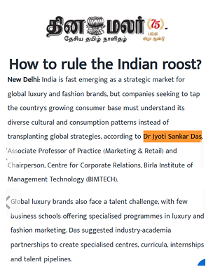

Article: Ethanol Blending: The Two Sides of a Story - Prof. Monika Jain - Governance Now

INDEX
Article: Ethanol Blending: The Two Sides of a Story - Prof. Monika Jain - Governance Now
Sr. No. | Publication | Link | Reach | PR Value
1 | Governance Now | https://www.governancenow.com/views/columns/ethanol-blending-the-two-sides-of-a-story | 1M | NA
Social Media
1 | Governance Now (X) | https://x.com/governancenow/status/2090110029009682589 | 12K | NA

https://www.governancenow.com/views/columns/ethanol-blending-the-two-sides-of-a-story

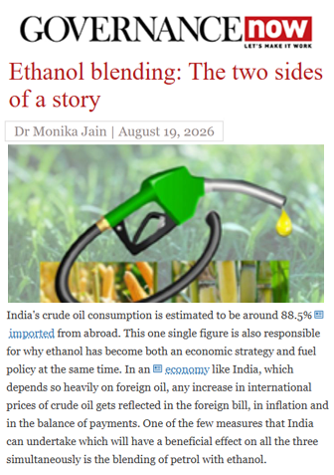

https://x.com/governancenow/status/2090110029009682589



Industry Story: PharmEasy expands into AI physiotherapy as investors push for profits - Prof. Jyoti Sankar Das - Fortune India

INDEX
Industry Story: PharmEasy expands into AI physiotherapy as investors push for profits - Prof. Jyoti Sankar Das - Fortune India
Sr. No. | Publication | Link | Reach | PR Value
1 | Fortune India | https://www.fortuneindia.com/business-news/pharmeasy-expands-into-ai-physiotherapy-as-investors-push-for-profits/154207 | 6.3 M | 2,55,200
TOTAL |  |  | 6.3 M | 2,55,200

https://www.fortuneindia.com/business-news/pharmeasy-expands-into-ai-physiotherapy-as-investors-push-for-profits/154207



Industry Story: If AI can give MBA Students the answers. What Should Business Schools Teach - Dr. T.V. Raman - ET Education

INDEX
Industry Story: If AI can give MBA Students the answers. What Should Business Schools Teach - Dr. T.V. Raman - ET Education
Sr. No. | Publication | Link | Reach | PR Value
1 | ET Education | https://education.economictimes.indiatimes.com/news/higher-education/if-ai-can-give-mba-students-the-answers-what-should-business-schools-teach/133397100?utm_source=latest_news&utm_medium=homepage | 36M | 2,55,200
TOTAL |  |  | 36M | 2,55,200

https://education.economictimes.indiatimes.com/news/higher-education/if-ai-can-give-mba-students-the-answers-what-should-business-schools-teach/133397100?utm_source=latest_news&utm_medium=homepage

